Bipolar Disorder

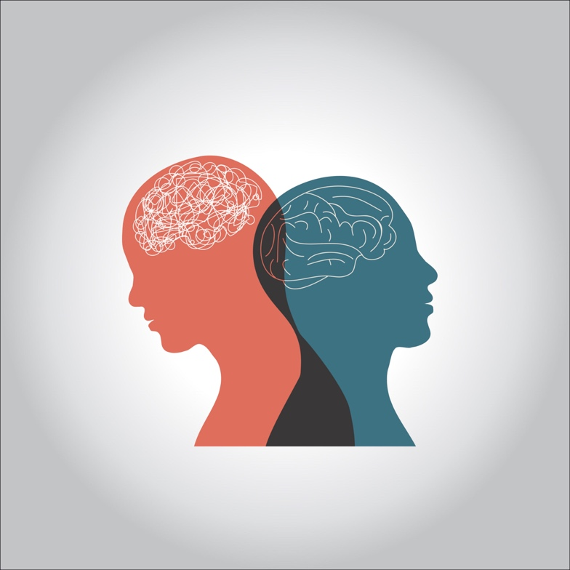

**Most people have emotional ups and downs from time to time. But if you have a brain condition called bipolar disorder, your feelings can reach abnormally high or low levels.**

**Sometimes you may feel immensely excited or energetic. Other times, you may find yourself sinking into a deep depression. Some of these emotional peaks and valleys can last for weeks or months.**

**There are four basic types of bipolar disorder:**

* **bipolar 1 disorder**
* **bipolar 2 disorder**
* **cyclothymic disorder (cyclothymia)**
* **other specified and unspecified bipolar and related disorders**

**Bipolar 1 and 2 disorders are more common than the other types of bipolar disorder.**

**Bipolar 1 vs. bipolar 2**

**All types of bipolar disorder are characterized by episodes of extreme mood. The highs are known as manic episodes. The lows are known as depressive episodes.**

**The main difference between bipolar 1 and bipolar 2 disorders lies in the severity of the manic episodes caused by each type.**

**A person with bipolar 1 will experience a full manic episode, while a person with bipolar 2 will experience only a hypomanic episode (a period that’s less severe than a full manic episode).**

**A person with bipolar 1 may or may not experience a major depressive episode, while a person with bipolar 2 will experience a major depressive episode.**



**What is bipolar 1 disorder?**

**You must have had at least one manic episode to be diagnosed with bipolar 1 disorder. A person with bipolar 1 disorder may or may not have a major depressive episode. The symptoms of a manic episode may be so severe that you require hospital care.**

**Manic episodes are usually characterized by the following:**

* **exceptional energy**
* **restlessness**
* **trouble concentrating**
* **feelings of euphoria (extreme happiness)**
* **risky behaviors**
* **poor sleep**

**What is bipolar 2 disorder?**

**Bipolar 2 disorder involves a major depressive episode lasting at least two weeks and at least one hypomanic episode (a period that’s less severe than a full-blown manic episode). People with bipolar 2 typically don’t experience manic episodes intense enough to require hospitalization.**

**Bipolar 2 is sometimes misdiagnosed as depression, as depressive symptoms may be the major symptom at the time the person seeks medical attention. When there are no manic episodes to suggest bipolar disorder, the depressive symptoms become the focus.**

**What are the symptoms of bipolar disorder?**

**As mentioned above, bipolar 1 disorder causes mania and may cause depression, while bipolar 2 disorder causes hypomania and depression.**

**Mania**

**A manic episode is more than just a feeling of elation, high energy, or being distracted. During a manic episode, the mania is so intense that it can interfere with your daily activities. It’s difficult to redirect someone in a manic episode toward a calmer, more reasonable state.**

**People who are in the manic phase of bipolar disorder can make some very irrational decisions, such as spending large amounts of money that they can’t afford to spend. They may also engage in high-risk behaviors, such as sexual indiscretions despite being in a committed relationship.**



**Hypomania**

**A hypomanic episode is a period of mania that’s less severe than a full-blown manic episode. Though less severe than a manic episode, a hypomanic phase is still an event in which your behavior differs from your normal state. The differences will be extreme enough that people around you may notice that something is wrong.**

**Officially, a hypomanic episode isn’t considered hypomania if it’s influenced by drugs or alcohol.**

**Depression**

**Depressive symptoms in someone with bipolar disorder are like those of someone with clinical depression. They may include extended periods of sadness and hopelessness. You may also experience a loss of interest in people you once enjoyed spending time with and activities you used to like. Other symptoms include:**

* **tiredness**
* **irritability**
* **trouble concentrating**
* **changes in sleeping habits**
* **changes in eating habits**
* **thoughts of suicide**

**What causes bipolar disorder?**

**Scientists don’t know what causes bipolar disorder. Abnormal physical characteristics of the brain or an imbalance in certain brain chemicals may be among the main causes.**

**As with many medical conditions, bipolar disorder tends to run in families. If you have a parent or sibling with bipolar disorder, your risk of developing it is higher.**

**Researchers also believe that severe stress, drug or alcohol abuse, or severely upsetting experiences may trigger bipolar disorder. These experiences can include childhood abuse or the death of a loved one.**

**How is bipolar disorder diagnosed?**

**A psychiatrist or other mental health professional typically diagnoses bipolar disorder. The diagnosis will include a review of both your medical history and any symptoms you have that are related to mania and depression. A trained professional will know what questions to ask.**

**It can be very helpful to bring a spouse or close friend with you during the doctor’s visit. They may be able to answer questions about your behavior that you may not be able to answer easily or accurately.**

**If you have symptoms that seem like bipolar 1 or bipolar 2, you can always start by telling your doctor. Your doctor may refer you to a mental health specialist if your symptoms appear serious enough.**

**A blood test may also be part of the diagnostic process. There are no markers for bipolar disorder in the blood, but a blood test and a comprehensive physical exam may help rule out other possible causes for your behavior.**

**How is bipolar disorder treated?**

**Doctors usually treat bipolar disorder with a combination of medications and psychotherapy.**

**Mood stabilizers are often the first drugs used in treatment. You may take these for a long time.**

**Lithium has been a widely used mood stabilizer for many years. It does have several potential side effects. These include low thyroid function, joint pain, and indigestion. It also requires blood tests to monitor therapeutic levels of the drug as well as kidney function. Antipsychotics can be used to treat manic episodes.**

**Your doctor may start you on a low dose of whichever medication you both decide to use in order to see how you respond. You may need a stronger dose than what they initially prescribe. You may also need a combination of medications or even different medications to control your symptoms.**

**All medications have potential side effects and interactions with other drugs. If you’re pregnant or you take other medications, be sure to tell your doctor before taking any new medications.**

**Writing in a diary can be an especially helpful part of your treatment. Keeping track of your moods, sleeping and eating patterns, and significant life events can help you and your doctor understand how therapy and medications are working.**

**If your symptoms don’t improve or get worse, your doctor may order a change in your medications or a different type of psychotherapy.**